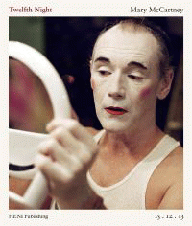 |  | Twelfth Night
 |  | Mary McCartney
Description
A stunning backstage photographic study of Mark Rylance and the cast of Shakespeare's Twelfth Night.
Bibliographic Details
- Hardback, GBP 24.99
- 17 Nov 2016
- 9780993316111
- 156 pages
- 268 x 230mm
- 50 Illustrations, unspecified
- PERFORMING ARTS / Theater / Direction & Production|PERFORMING ARTS / Theater / Direction & Production|PHOTOGRAPHY / Subjects & Themes / Celebrations & Events|PHOTOGRAPHY / Subjects & Themes / Portraits & Selfies
- HENI Publishing

About the Authors
Mary McCartney's photographic work focusses on discovering those rare moments of unguarded, emotionally charged intimacy that offers us a new insight to the subject. Her work has concentrated on the world of portrait and candid reportage photography and is suffused with a deep personal investment that captures the creative chemistry between photographer and subject.

