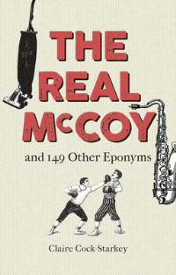 |  | The Real McCoy and 149 other Eponyms
 |  | Claire Cock-Starkey
Description
The English language is rich with eponyms words that are named after an individual some better known than others. This book features 150 of the most interesting and enlightening specimens, delving into the origins of the words and describing the fascinating people after whom they were named. Eponyms are derived from numerous sources. Some are named in honour of a style icon, inventor or explorer, such as pompadour, Kalashnikov and Cadillac. Others have their roots in Greek or Roman mythology, such as panic and tantalise. A number of eponyms, however, are far from celebratory and were created to indicate a rather less positive association into this category can be filed boycott, Molotov cocktail and sadist. Encompassing eponyms from medicine, botany, invention, science, fashion, food and literature, this book uncovers the intriguing tales of discovery, mythology, innovation and infamy behind the eponyms we use every day. The perfect addition to any wordsmiths bookshelf.
Bibliographic Details
- Hardback, GBP 9.99
- 12 Oct 2018
- 9781851244980
- 144 pages
- 184 x 118mm
- $fv_illus$
- LANGUAGE ARTS & DISCIPLINES / Linguistics / Etymology
- Bodleian Library

About the Authors
Claire Cock-Starkey is the author of The Book Lovers Miscellany (2017) and A Library Miscellany (2018).

