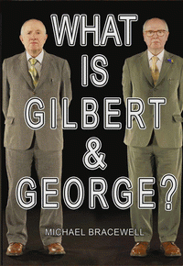 |  | What Is Gilbert & George?
 |  | Michael Bracewell
Description
In answering the question posed by its title, and drawing on his twenty year relationship with the artists, Michael Bracewell is the first writer to engage directly with Gilbert & George to understand why they have devoted their lives exclusively and continuously - to the vision of art they conceived within months of first meeting. What emerges piece by piece is a portrait of Gilbert & George as two men who are infinitely more intense, strange, determined and alone than their longstanding public image suggests.
Bibliographic Details
- Hardback, GBP 9.95
- 02 Nov 2017
- 9781912122028
- 180 pages
- 244 x 160mm
- 80 Illustrations, unspecified
- ART / Individual Artists / Monographs|ART / Individual Artists / Monographs|ART / Individual Artists / Artists' Books
- HENI Publishing

