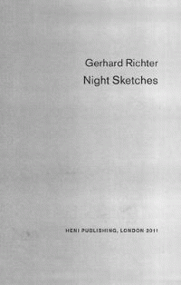 |  | Cage
 |  | Six Tableaux de Gerhard Richter
 |  | Gerhard Richter, Robert Storr
Description
The Cage paintings were conceived as a single coherent group, and displayed for the first time at the Venice Biennale in 2007. Their titles, Cage (1) (6), pay homage to the American avant- garde composer John Cage (1912 92). In his Lecture on Nothing , Cage famously declared I have nothing to say and I m saying it . Richter is equally suspicious of ideologies and any claim to absolute truth. He shies away from giving psychological interpretations to his paintings, preferring to allow viewers and critics to make up their own minds. Leading critic Robert Storr considers the importance of the Cage paintings within Richter s practice and within the wider context of abstract art. A series of extraordinary, detailed photographs document the development of each painting, day by day, and show the artist at work on these monumental canvases, giving unique insight into his working methods.
Bibliographic Details
- Hardback, GBP 25.00
- 13 Oct 2011
- 9780956404176
- 200 pages
- 259 x 260mm
- $fv_illus$
- ART / History / Contemporary (1945-)|ART / History / Contemporary (1945-)|ART / Individual Artists / Monographs|ART / Collections, Catalogs, Exhibitions / General
- HENI Publishing

About the Authors
Robert Storr is Dean of the Yale University School of Art and was formerly a curator at the Museum of Modern Art, New York. He is the author of 'Gerhard Richter: 40 Years of Painting' and 'Modern Art Despite Modernism', among many other publications.

